**8.2.1**

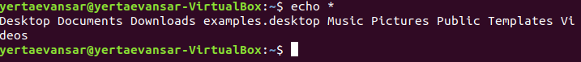

**8.2.2**

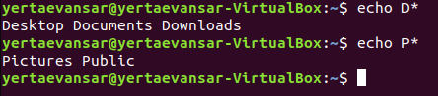

**8.2.3**



**8.2.4**



**8.2.5**



**8.2.6**



**8.2.7**



**8.2.8**

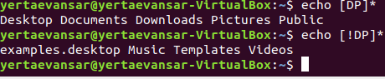

**8.2.9**

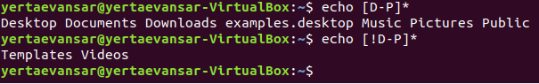

**8.3.1**

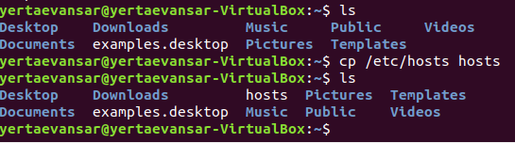

**8.3.2**

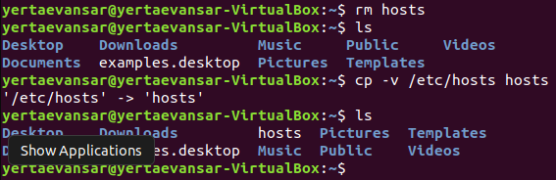

**8.3.3**

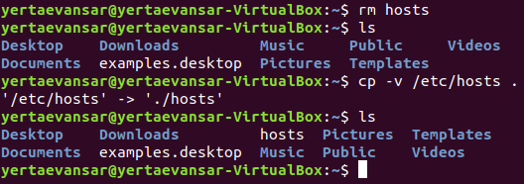

**8.3.4**

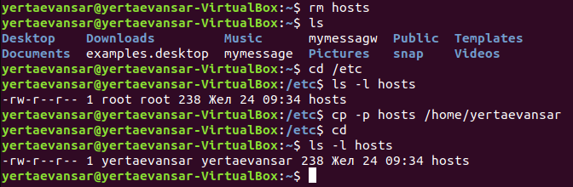

**8.3.5**

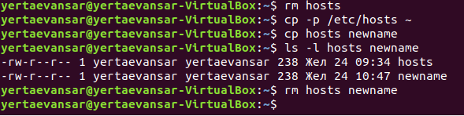

**8.3.6**

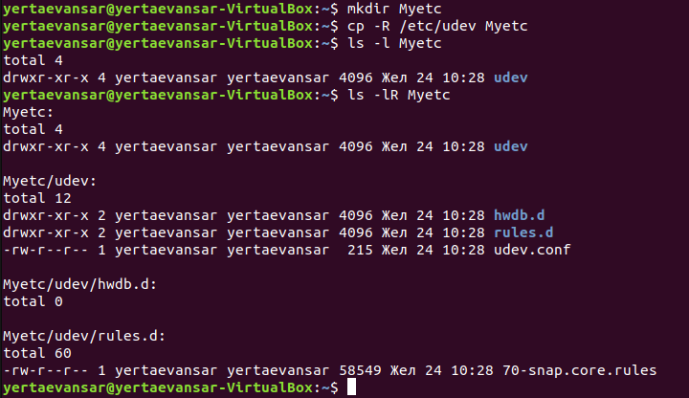

**8.3.7**

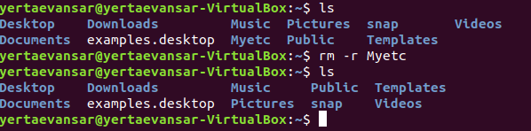

**8.3.8**

